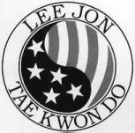
 |  |  |  | STUDENT NAME
 |  |  |  | DATE

STUDENT PROGRESS REPORT
DEAR PARENTS AND TEACHERS,

OUR MAIN OBJECTIVE AT LEEJON TAE KWON DO IS TO DEVELOP BLACK BELTS. NOT ONLY IN MARTIAL ARTS, BUT IN LIFE AS WELL. THIS MEANS STRIVING FOR THEIR BEST IN EVERYTHING THEY DO. THE PERSON NAMED BELOW HAS REACHED THEIR SHORT TERM GOAL OF TESTING FOR THEIR NEXT BELT LEVEL AS A REQUIREMENT FOR TESTING THEY MUST HAVE PASSING GRADES FOR THIS GRADING PERIOD.

- MY DAUGHTER/SON ___________________________ HAS BEEN COOPERATING AT HOME: YES _____ NO _____

- MY STUDENT HAS BEEN DOING SATISFACTORY WORK, RECEIVING PASSING GRADES AND IS A GOOD CITIZEN IN THE CLASSROOM
YES _____ NO _____

 | PERIOD | EXCEEDS | MEETS |  | NEEDS IMPROVEMENT
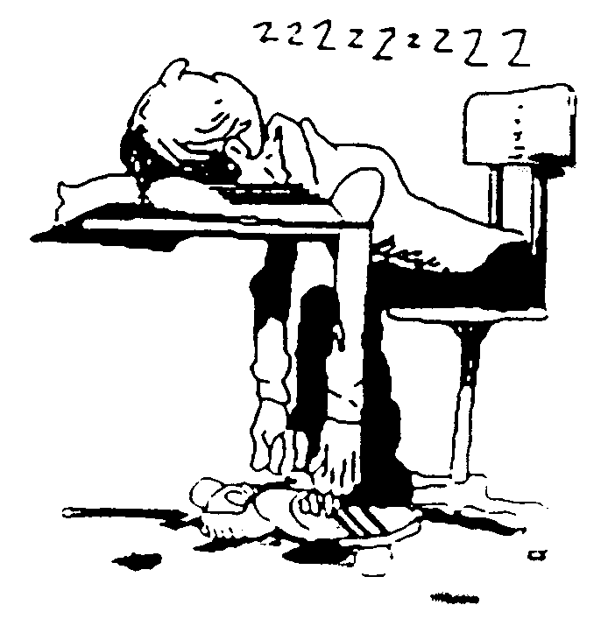
THANK YOU VERY MUCH

LEONARD ORTEZ
HEAD INSTRUCTOR

Motivation Is Our Specialty



LEE JON
Tae Kwon Do
STUDENT TEST REPORT CARD

Date: | Student Name: |  |  |  | Final Grade:
Forms |  | Left GRADE Right |  | Basic Kicks |  | Left GRADE Right
KIBON 1 |  |  |  | FRONT
KIBON2 |  |  |  | SWING
KIBON 3 |  |  |  | SIDE
PALGWE 1 / TAEGUK 1 |  |  |  | BACK
PALGWE 2 / TAEGUK 2 |  |  |  | Sliding Kicks
PALGWE 3 / TAEGUK3 |  |  |  | FRONT
PALGWE 4 / TAEGUK 4 |  |  |  | SWING
PALGWE 5 / TAEGUK 5 |  |  |  | SIDE
PALGWE 6 / TAEGUK 6 |  |  |  | BACK
PALGWE 7 / TAEGUK 7 |  |  |  | Pop Kicks
PALGWE 8 / TAEGUK 8 |  |  |  | FRONT
CHUMO 1 |  |  |  | SWING
CHUMO 2 |  |  |  | SIDE
CHUMO 3 |  |  |  | BACK
CHUMO 4 |  |  |  | Jump Kicks
Advanced Forms |  |  |  | FRONT
 |  |  |  | SWING
 |  |  |  | SIDE
Sparring Techniques |  |  |  | BACK
2 STEP SPARRING |  |  |  | Advanced Kicks
4 STEP SPARRING
3 STEP SPARRING
1 STEP SPARRING
FREE SPARRING |  |  |  | Total Points 2
Miscellaneous |  |  |  | Total Points 1
STUDENT CREED |  |  |  | Final Total
KI-YAP |  |  |  | A+=5.0 A=4.0 B=3.0 C=2.0 D=1.0
CONTROL |  |  |  | 1.0 GPA is a FAIL and will be allowed to retest
BALANCE |  |  |  | PLEASE READ AND SIGN BELOW
ATTITUDE TERMS |  |  |  | I do hereby affirm and say:  - I do apply for the rank judgment paying  REQUIRED AMOUNT based on my belt level for the testing fee and know that this fee is non-refundable.  - Testing fees must be submitted before testing along with this form and parent teacher approval form.  - The LEEJON Tae Kwon Do Association its staff U.T.A. and U.S.T.U are NOT responsible for any accidents, which may occur during this judgment.  _______________________________  STUDENT’S/PARENT SIGNATURE
BREAKING

Basics
STANCES
ATTACKS
DEFENSES
OTHER
Total Points 1
Current Rank:
Belt Size:
Judged By:
Comments:

